Project Design Phase-II
Data Flow Diagram & User Stories

Date | 26 September 2026
Team ID | SWTID-2026-9376
Project Name | FitTrack AI – Personalized Fitness Recommendations Powered by AI
Maximum Marks | 4 Marks

System Flow:
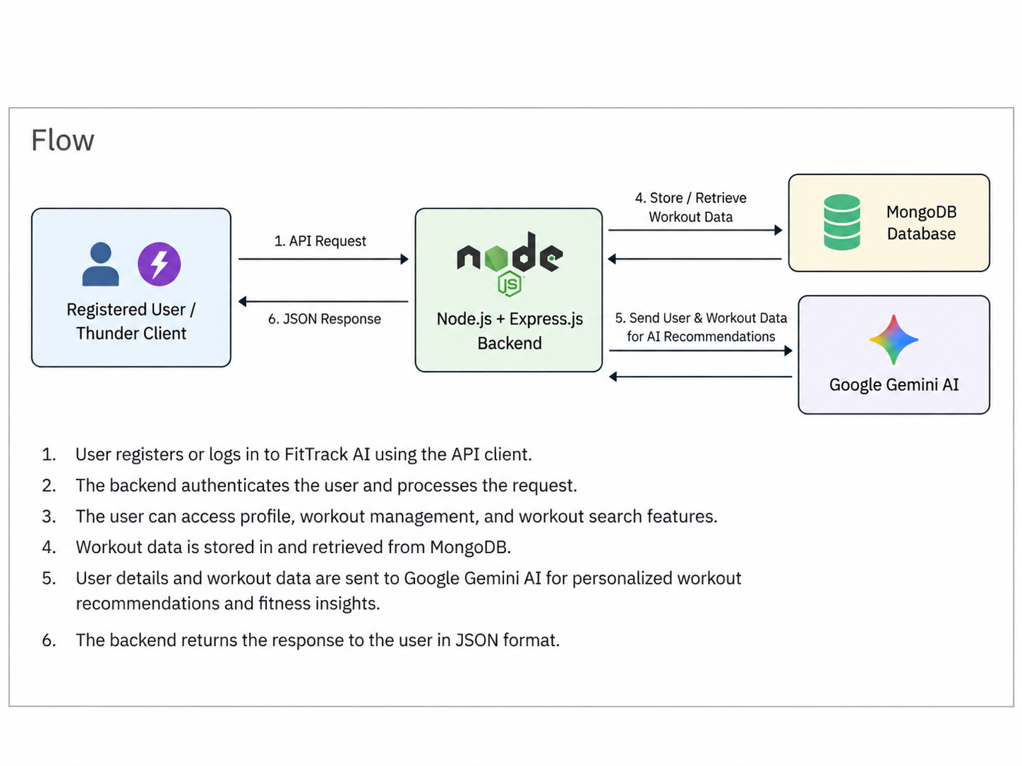

Data Flow Diagrams:
A Data Flow Diagram (DFD) is a traditional visual representation of the information flows within a system. A neat and clear DFD can depict the right amount of the system requirement graphically. It shows how data enters and leaves the system, what changes the information, and where data is stored.

DFD Level 0:  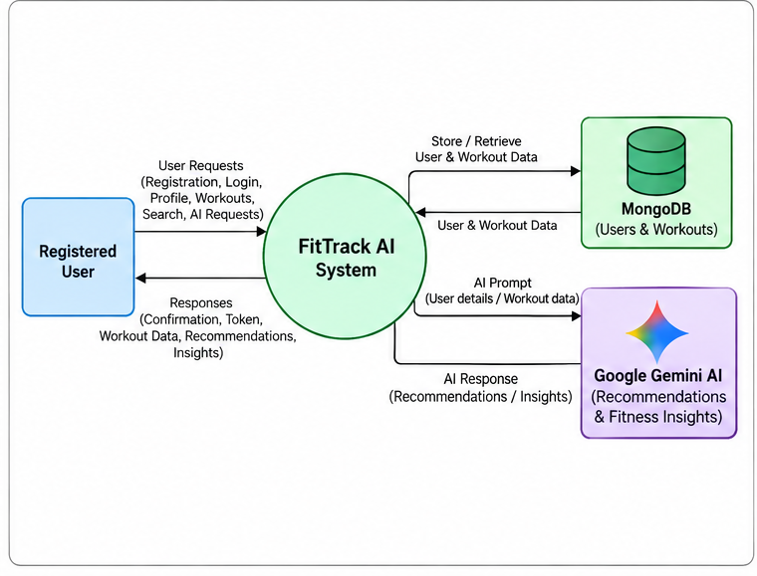 | DFD Level1:  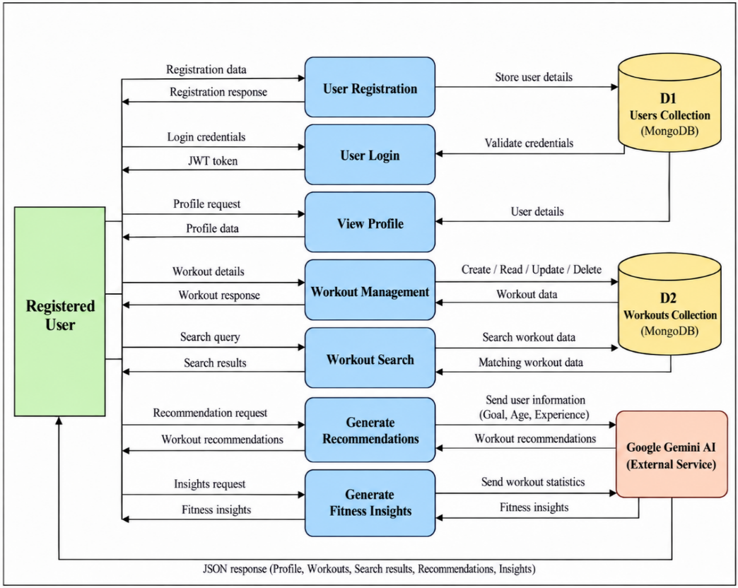

User Stories
User Type | Functional Requirement (Epic) | User Story Number | User Story / Task | Acceptance criteria | Priority | Release
Registered User | Registration | USN-1 | As a user, I can register using name, email, and password. | Account is created successfully. | High | Sprint-1
Registered User | Login | USN-2 | As a user, I can log in using email and password. | Valid credentials return a JWT token. | High | Sprint-1
Registered User | Profile | USN-3 | As an authenticated user, I can view my profile. | Profile details are returned successfully. | Medium | Sprint-1
Registered User | Workout Management | USN-4 | As a user, I can add a workout record. | Workout is stored in MongoDB. | High | Sprint-1
Registered User | Workout Management | USN-5 | As a user, I can view my workout records. | Stored workouts are returned. | High | Sprint-1
Registered User | Workout Management | USN-6 | As a user, I can retrieve a workout using its ID. | Selected workout details are returned. | Medium | Sprint-1
Registered User | Workout Management | USN-7 | As a user, I can update an existing workout. | Updated workout is saved successfully. | High | Sprint-1
Registered User | Workout Management | USN-8 | As a user, I can delete a workout record. | Selected workout is removed successfully. | High | Sprint-1
Registered User | Workout Search | USN-9 | As a user, I can search my workouts using a search term. | Matching workout records are returned. | Medium | Sprint-1
Registered User | AI Recommendation | USN-10 | As a user, I can receive personalized workout recommendations. | Gemini AI returns recommendations based on age, goal, and experience level. | High | Sprint-2
Registered User | Fitness Insights | USN-11 | As a user, I can receive fitness insights from my workout statistics. | Gemini AI returns useful insights and improvement suggestions. | High | Sprint-2

